Lab: Surface Temperature and Luminosity of Stars:
Wein’s Law and the Stephan-Boltzmann Law

Learning Objectives
- To understand thermal spectra
- To understand Wien’s Law and the Stephan-Boltzmann Law
- To understand how thermal spectra can be used to evaluate the surface temperature of a star
- To understand how temperature and radius of a star determine a star’s luminosity

Introduction: We have learned how by studying the line spectrum reaching us from a star we can determine what a star is made of. In this activity we will learn how light from a star can tell us its surface temperature and how much energy per second the star is emitting – its luminosity.

Light that is emitted from a hot object made of many closely packed atoms forms a continuous spectrum, called a thermal spectrum. The object can be a light bulb, a person, a table, a star, etc. The range of wavelengths emitted and the relative intensity for each wavelength are dependent on the temperature of the object.

In this activity we will use a PhET simulation to study the thermal spectra of stars in order to understand the relationship between these spectra and temperature. We will see how this relationship results in two laws that describe these spectra -- Wein’s Law and the Stephan-Boltzmann Law.

Go to http://phet.colorado.edu/sims/blackbody-spectrum/blackbody-spectrum_en.html

As you work through this activity, either answer the questions on a separate page – neatly handwritten or typed -- or put answers in bold beneath the questions.

Part 1: Understanding the graph

This simulation plots a graph that describes the spectrum emitted by a hot object. The horizontal axis indicates the wavelength of the emitted photons and the vertical axis indicates the amount of energy per second (power) emitted by one square meter of the object at a particular wavelength.

To investigate this further, set the temperature to 5800 K. Either move the slider or type the numbers in the temperature box. 5800 K is approximately the surface temperature of the Sun.

Note that the horizontal axis specifies the emitted wavelengths (λ) in units of micrometers, µm. One micrometer equals 1000 nanometers. (1µm = 1000 nm.) For example, look at the visible spectrum. The longest wavelength of the visible spectrum is approximately 0.7µm = 0.7x1000nm or 700 nm.

Question 1. Approximately, what the shortest visible wavelength? Express your answer in µm and nm.
0.4 µm = 0.7x1000nm or 400 nm

Observe the peak of the curve. The Sun emits the most energy at this wavelength. We will label this wavelength λ_{peak}-- the wavelength where the curve is at its peak.

Question 2: What color corresponds to λ_{peak}?
Blue Light

Question 3. Approximately, what is the value for λ_{peak}? Express your answer in µm and nm. (Check the box “show ruler” and use the ruler to help approximate λ_{peak}.)
0.5 µm = 0.5x1000nm or 500nm.

The vertical axis indicates for each wavelength the amount of energy per second emitted by one square meter of the surface of the emitting object, the Sun in this setting. Recall that “energy per second” is “power,” measured in watts, W. MW are “megawatts.” 1MW = 1 Million W. Thus the vertical units are MW/m². Note that the only values on the graph are 0 and 100. You can use the ruler to estimate values in between. For example, to measure value for the peak wavelength, rest the bottom of the ruler on the horizontal axis, and note that 30cm corresponds to 100 MW/m². The peak measures 24 cm. So the value at this wavelength = (24/30) x 100 MW/m² = 80 MW/m².

Hit the “save” button!

Enter your values for the Sun in Table 1 on the next page.

Part 2: Other Stars at other Surface Temperatures

A. Change the temperature to 3800K. Compare this curve to the saved one for the Sun.

Question 4: In what two ways does this peak differ from that of the Sun?
The peak wavelength is higher while its energy is lower, compared to the Sun.
For easier viewing, magnify the curve by pressing the + button on the left. Note that the maximum reading on the vertical axis changes. Make measurements to complete the Table 1 entries for this temperature.

B. Change the temperature to 6600K. Compare this curve to the saved one for the Sun. For easier viewing, press the - button on the left. Make measurements to complete the Table 1 entries for this temperature.

Question 5: In what two ways does this peak differ from that of the Sun?

The peak wavelength is lower while energy is higher, compared to that of the Sun.
C. Make measurements to complete the Table 1 entries for a temperature of 8300 K, adjusting the scales as necessary.

Table 1: Thermal Spectra Characteristics for Different Temperatures

Temperature | λ_{peak} (nm) | λ_{peak} (color, UV, or IR) | Peak Energy/sec/m²  (MW/m²)
3800 K | 700 nm | Red color | 10 MW/m²
5800 K (Sun) | 500 nm | Light Blue color | 80 MW/m²
6600 K | 425 nm | Dark Blue color | 158 MW/m²
8300 K | 350 nm | UV | 493 MW/m²

Part 3: Wien’s Law

A. Qualitative discussion

Question 6: Based on your values in Table 1, how does the value of λ_{peak} change as the temperature increases?

Wien’s Law states: Hotter objects emit photons with a higher average energy, which means a higher frequency and, therefore, a shorter wavelength.

λ_{peak} value decreases with increase in temperature.

Question 7: Do the values in Table 1 support this law or not? Explain your choice.
The values do support this law.

From the data, shorter wavelength was recorded from a higher temperature and higher energy, which abides with Wien’s Law.

B. Quantitative discussion

Quantitatively, Wien’s law reflects this inverse relationship between temperature and peak wavelength. It states that if wavelength is measured in nm and temperature is measured in Kelvin, then

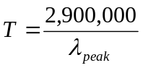

Use the values you measured for λ_{peak} and Wien’s law to determine T and compare to the values from the PhET. Enter the values in Table 2.

Table 2: Comparison with Wien’s Law

Temperature  (From PhET) | λ_{peak} (nm) | Surface Temperature  (Wien’s Law) | % error
3800 K | 700 nm | 4,142.85 K | 9.02
5800 K (Sun) | 500 nm | 5,800 K | 0
6600 K | 425 nm | 6823.53 K | 3.39
8300 K | 350 nm | 8285.71 K | 0.17

Part 4: The Stephan-Boltzmann Law—
A. Qualitative discussion

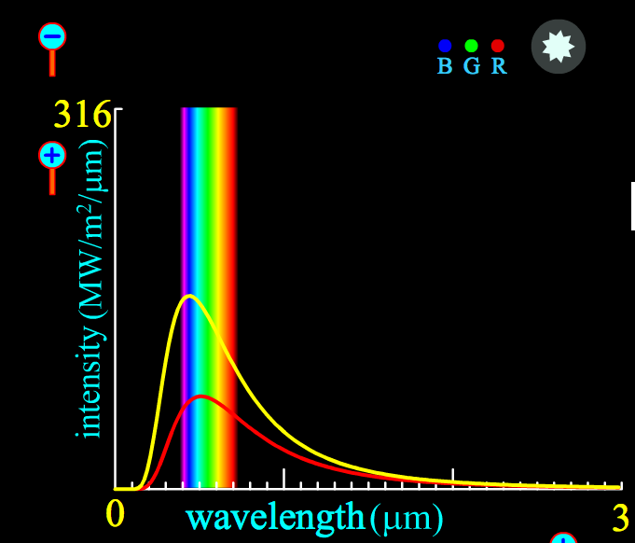

The picture above is a screen shot of the 5800K (red) and 6600K(yellow) thermal spectra.

Question 8: Which radiates more MW/m² at infrared wavelengths?

6600K thermal spectra

Question 9: Which radiates more MW/m² at visible wavelengths?
6600K thermal spectra

Question 10: Which radiates more MW/m² at ultraviolet wavelengths?

6600K thermal spectra

The Stephan-Boltzmann Law states: Each square meter of a hotter object’s surface emits more light at all wavelengths.

Question 11: Do your observations of this figure support this law or not? Explain your choice.
The figures do support the law.

For all the radiates, the temperature was high in all wavelengths.

B. Quantitative discussion
The Stephan-Boltzmann law can be expressed mathematically as follows:

The energy per second (power) emitted by one square meter of a star’s surface =

where the temperature T is measured in K and the constant = 5.7 x 10⁻⁸ watt/(m² K⁴).

We will not be “putting numbers into this equation.” We are most interested in noting the following:
- The energy emitted per second varies as the fourth power of the temperature so that, for example, doubling the temperature results in 2x2x2x2 = 16 times as much energy per second.
- This only tells us the energy per second emitted by one square meter of the star’s surface.
Part 5: Luminosity

Luminosity, L, is the total power (energy per second) that a star radiates into space.

The Stephan-Boltzmann law tells us how much energy per second one square meter of the star radiates into space, so to obtain the total energy radiated we must multiply by the surface area of the star, 4πR².

L = T⁴ x 4πR²

where T is in Kelvin, R, the radius of the star is in m (meters) and L is in watts.

Question 12. What two properties of a star determine its luminosity?
Temperature and Surface Area.

Question 13. Can two stars have the same surface temperature and different luminosities? Explain.
Yes.

Depending on their different surface area/radius of a given star, the two can differ in luminosity despite sharing the same temperature. This means the larger surface area equates to higher luminosity

Question 14. Can two stars have the same luminosity and different surface temperatures? Explain.

Yes.

The proportionally of stars in this case is based on their surface area. A small star, with higher surface temperatures and a large star with lower surface temperatures, can have the same luminosity.
Additional Questions. This portion must be done independently.

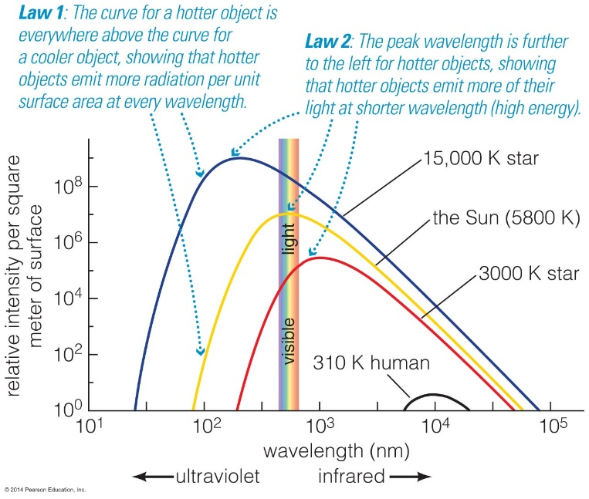

1. (15 pts) The figure above, from your text, summarizes Wien’s Law and the Stephan-Boltzmann Law.

- Use Wien’s Law to determine_{peak} for the 15,000 K star. (Show calculation).

peak ג = 2.898 x 10³
T(K)

=2.898 x 10³ m
15000

= 193nm

- This 15,000 K star peaks in the ultraviolet. It is approximately the same distance from Earth as a 5800 K star that peaks in the visible. Which star is easier to see with the naked eye and why?
5800 K star is visible with a naked eye.

Reason being the peak for the 15,000 K star is in ultraviolet light, while the peak for the 5800 K star is in visible light.

c. True or False: The Stephan – Boltzman law says that all stars at the same temperature emit the same amount of light. Explain your choice.
False.

The law proposes that all stars with equivalent temperature radiate the same amount of light per unit surface area. Additionally, the luminosity of the star depends on the size of the star, thus not all stars at the same temperature emit the same amount of light.

2. (15 pts) Numerically evaluate the temperature of each of the 3 stars with spectra pictured below:

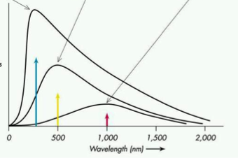
Estimated Peak Emission Wavelengths: 280nm, 500nm, 1000nm

Therefore;

T1(K) = 2.898 x 10³
280 nm
= 10349.2 K

T2(K) = 2.898 x 10³
500 nm
= 5795.5 K

T1(K) = 2.898 x 10³
1000 nm
= 2897.8 K
From http://www.google.com/imgres?imgurl&imgrefurl=http%3A%2F%2Fwww.oswego.edu%2F~kanbur%2Fa100%2Flecture13.html&h=0&w=0&tbnid=sPlijL5xKSJEJM&tbnh=197&tbnw=256&zoom=1&q=stellar%20spectra&docid=mvxpUY0YuJvHLM&ei=qMQpU5jLIO-g0gHXroGYCg&ved=0CAgQ

3. (5 pts) Refer to the spectra below for stars A and B. Note that this is a plot of total energy emitted per second vs. wavelength.

- Which star is hotter? Explain.
Both are equally hot.

Both peak at the same wavelength, implicating that they have the same frequency and energy and eventually the same temperature.

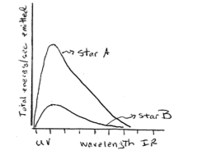
4. It is possible for a star to be very luminous and have a thermal spectrum that peaks in the infrared.

Yes, it is possible.

For example, galaxies at the highest infrared luminosities called as Luminous and Ultra Luminous Infrared Galaxies. (LIRGs and ULIRGs,)

